SCHOOL PORTAL ERP SYSTEM

Screen Specification Document

Project Title | School Portal ERP System
Document Name | Screen Specification Document
Version | v1.0
Date | July 2026
Prepared By | Business Analyst

1.Introduction
The Screen Specification Document provides a detailed description of the user interface screens for the School ERP system. It defines the layout, navigation, screen elements, user interactions, and functionality of each module to ensure consistency during development, testing, and deployment. This document serves as a reference for developers, testers, designers, and stakeholders throughout the project lifecycle.
2.Purpose
The purpose of this document is to specify the functional behavior and user interface requirements of each screen in the School ERP system. It helps ensure that all application screens are designed and implemented consistently while meeting the business requirements and providing a user-friendly experience across web and mobile platforms.
3. User Roles
The School ERP system supports the following user roles:
Student
Students can log in to access their dashboard, view attendance records, submit assignments, check examination results, receive notifications, and manage their profile information.
Teacher
Teachers manage student attendance, create and evaluate assignments, upload examination marks, send notifications, and monitor student academic performance.
Parent
Parents can monitor their child's attendance, assignment status, examination results, notifications, and overall academic progress through the parent dashboard.
Admin
The Admin manages the overall system, including user accounts, student, teacher, and parent records, attendance, assignments, examinations, notifications, reports, and system configuration. The Principal accesses the system through the Admin portal using separate credentials with role-based permissions.
4. Screen Specifications
Each screen implemented in the application is documented below in a consistent format covering its purpose, applicable user roles, on-screen components, validation rules, and navigation behaviour. Screenshots captured from the working application are included for reference.
SCR-001 – Login Screen
Purpose
Allows users to securely log in to the School ERP system by selecting their role and entering valid credentials.
Users
- Student
- Teacher
- Parent
- Admin
- Principal (via Admin account)
Components
- Role selector – Admin / Teacher / Student / Parent
- Email Address field
- Password field with show/hide toggle
- Remember Me checkbox
- Forgot Password link
- Sign In button
Validation
- Valid email format required
- Password field cannot be empty
- “Invalid Credentials” message shown on incorrect email/password combination
- Account is temporarily locked after multiple failed attempts, with a live countdown (e.g. “Too many failed attempts. Try again in 29 seconds.”) shown to the user
Navigation
- Successful login → role-specific Dashboard (Admin Dashboard, Teacher Dashboard, Student Dashboard, or Parent Dashboard)
- Forgot Password → Password Reset flow

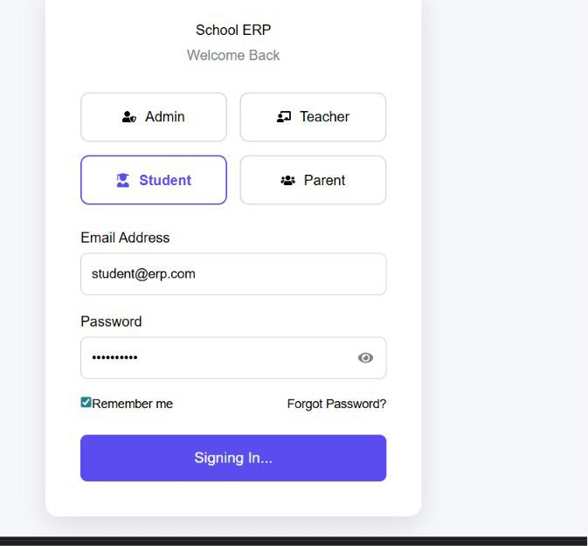
Login screen – Student role selected, signing in

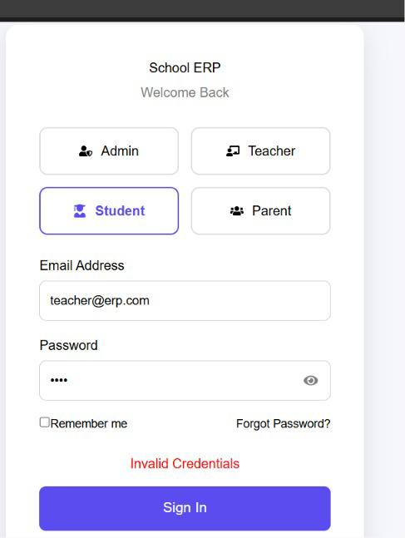
Login screen – Invalid Credentials error

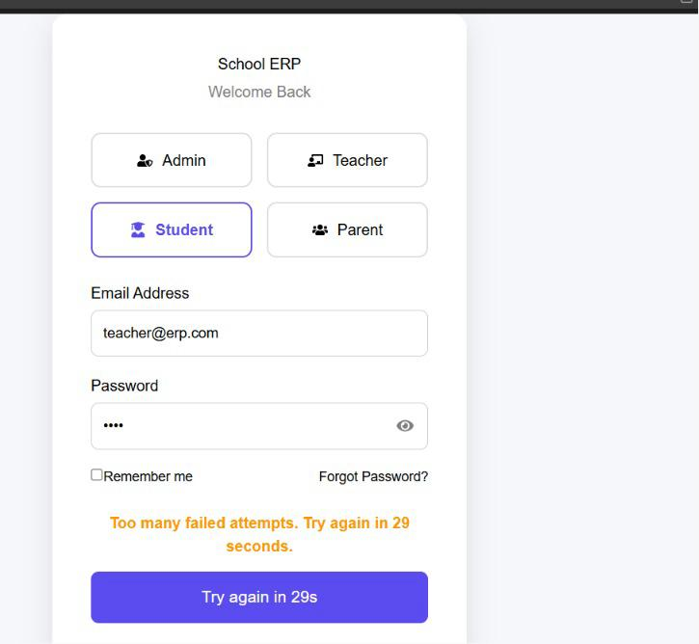
Login screen – account temporarily locked after failed attempts

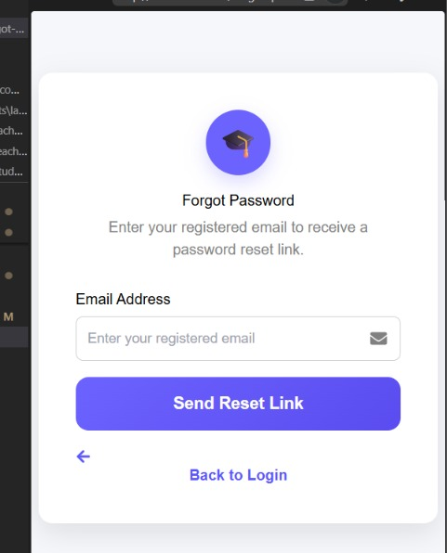
Enter the registered email address to receive a password reset link
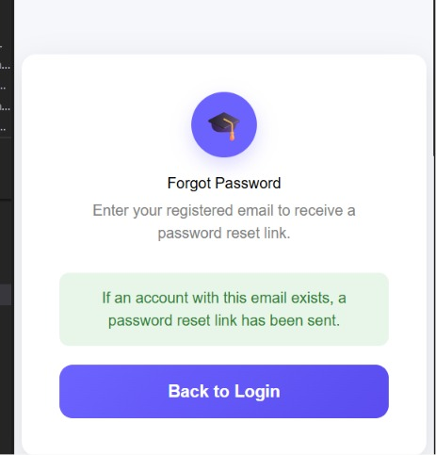
Navigate back to the login screen after completing the password reset process

SCR-002 – Admin Dashboard
Purpose
Gives the administrator a consolidated, real-time overview of all students, teachers, and parents registered in the system, along with recent system activity.
Users
- Admin
- Principal (via Admin account)
Components
- Left navigation menu – Dashboard, Students, Teachers, Parents
- Global search bar for students, teachers, and parents
- Notification bell with unread indicator
- Summary Overview cards – Total Students, Active Students, Total Teachers, Active Teachers, Total Parents, Active Parents
- “Active vs Inactive by Category” progress bars for Students, Teachers, and Parents
- System Snapshot panel – Total Records, Total Active, Total Inactive, Activities Logged
- Current date display
Validation
- Dashboard figures update automatically as records are added, edited, or deactivated
- Only authenticated Admin sessions can access this screen
Navigation
- Students card / menu item → Student Management screen (SCR-003)
- Teachers menu item → Teacher Management screen (SCR-004)
- Parents menu item → Parent Management screen (SCR-005)
- Profile icon → Admin account options / Sign Out

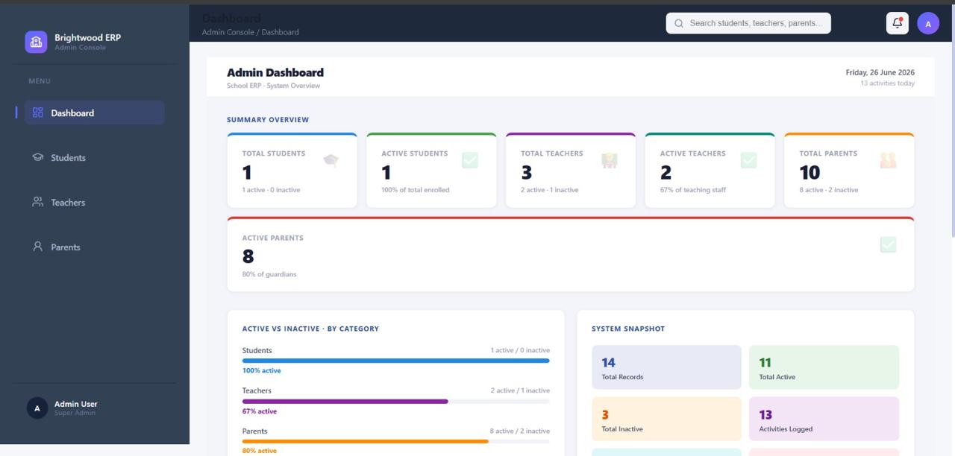
Admin Dashboard

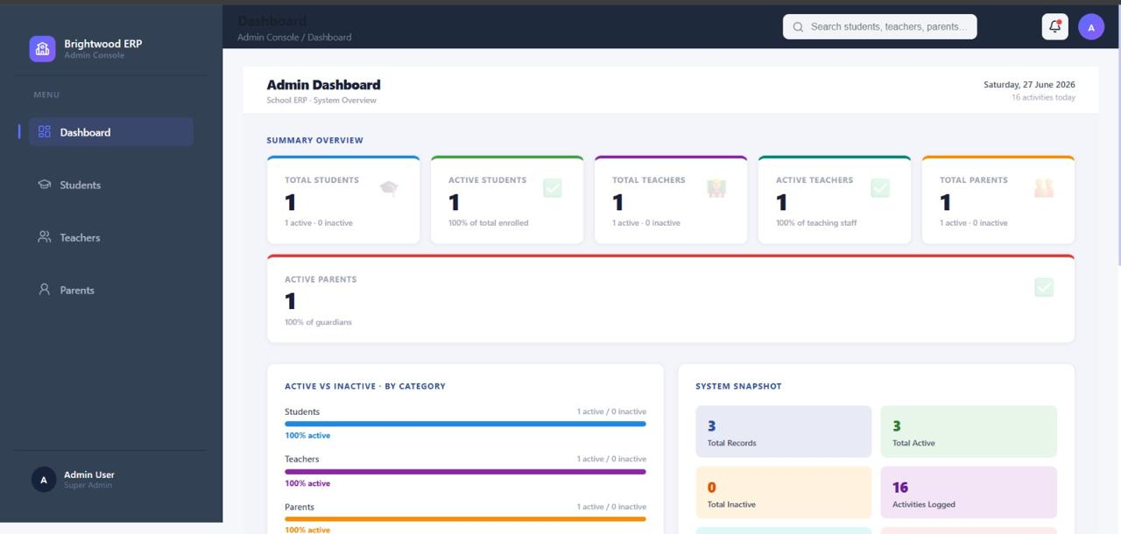
Admin Dashboard after data changes

SCR-003 – Student Management
Purpose
Enables the administrator to view, search, add, edit, and deactivate student records.
Users
- Admin
Components
- Summary cards – Total Students, Active Students, Inactive Students
- “+ Add Student” button
- Search bar (by ID, Name, Class, Phone, or Email)
- Active Students / Inactive Students tabs
- Student records table – Student ID, Name, Class/Section, Parent, Phone, Email, Admission date, Status, Actions
- Edit and Deactivate action icons per row
- Pagination controls
Validation
- Search filters the table in real time against the entered term
- Deactivating a student moves the record to the Inactive Students tab rather than deleting it
Navigation
- Add Student → Add Student form
- Edit icon → Edit Student form pre-filled with existing data
- Dashboard menu item → back to Admin Dashboard (SCR-002)
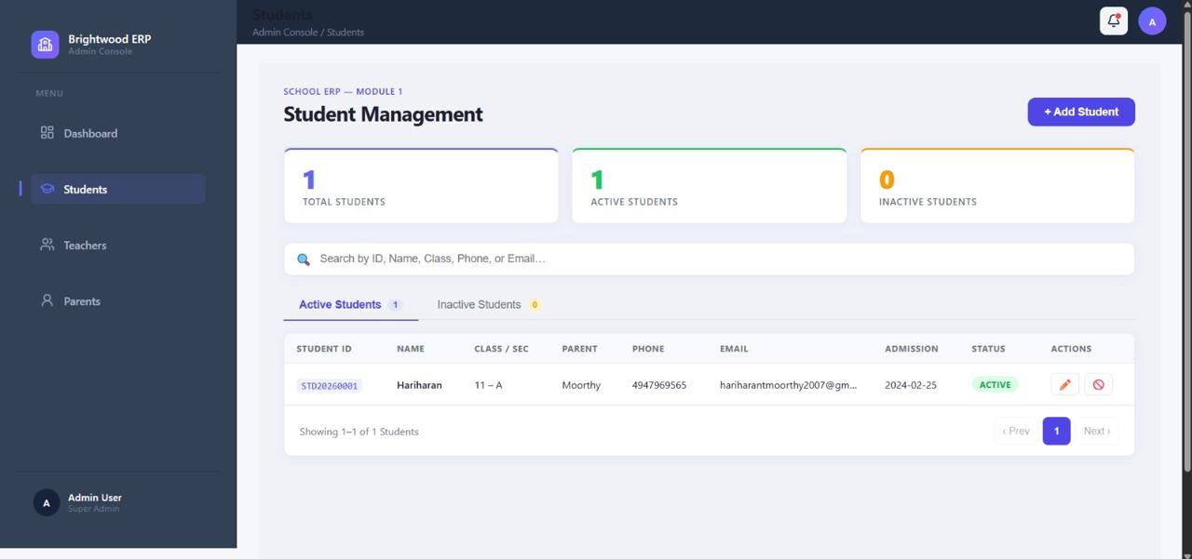
Student Management – Active Students list
SCR-004 – Teacher Management
Purpose
Enables the administrator to view, search, add, edit, and deactivate teacher records.
Users
- Admin
Components
- Summary cards – Total Teachers, Active, Inactive
- “+ Add Teacher” button
- Search bar (by ID, name, subject, email, phone)
- Active Teachers / Inactive Teachers tabs
- Teacher records table – Teacher ID, Name, Subject, Qualification, Total Experience, School Experience, Phone, Email, Status, Joining Date, Actions
- Edit and Deactivate action buttons per row
- Pagination controls
Validation
- Search filters the table in real time
- Records follow a soft-delete approach – deactivated teachers are retained in the Inactive Teachers tab
Navigation
- Add Teacher → Add Teacher form
- Edit → Edit Teacher form pre-filled with existing data
- Dashboard menu item → back to Admin Dashboard (SCR-002)
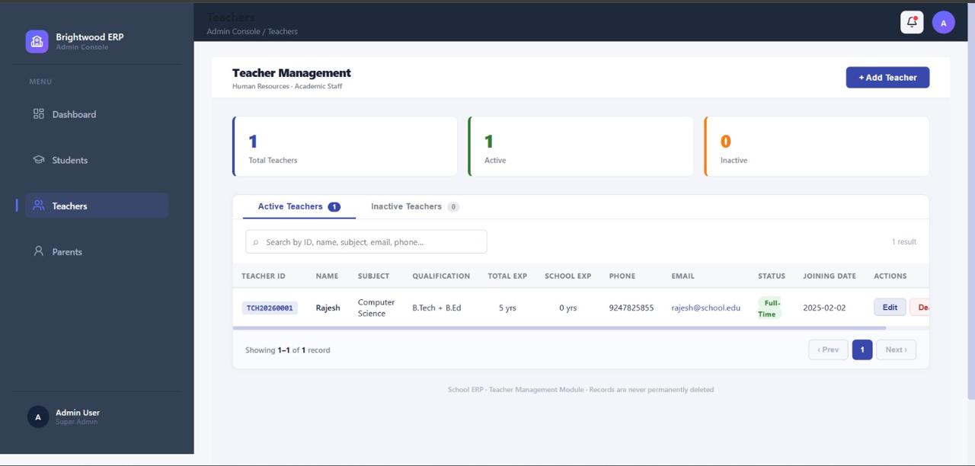
Teacher Management – Active Teachers list

SCR-005 – Parent Management
Purpose
Enables the administrator to view and manage parent/guardian records and their linked children.
Users
- Admin
Components
- Summary cards – Total Parents, Active Parents, Inactive Parents, Total Children
- Search bar (by ID, name, student, email, phone, relationship)
- Active Parents / Inactive Parents tabs
- Parent records table – Parent ID, Parent Name, Relationship, Children, Number of Children, Occupation, Phone, Alternate Phone, Email
- Pagination controls
Validation
- Search filters the table in real time
- Records use a soft-delete architecture – no record is permanently deleted from the system
Navigation
- Dashboard menu item → back to Admin Dashboard (SCR-002)
- Student name link (e.g. under Children) → corresponding Student record
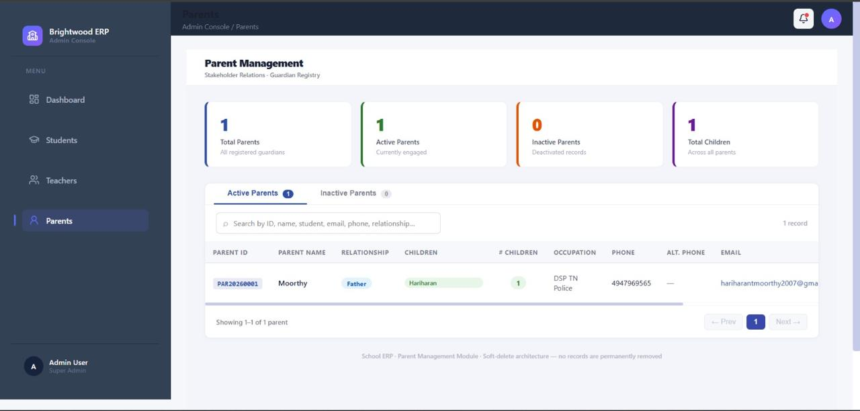
Parent Management – Active Parents list
SCR-006 – Student Dashboard
Purpose
Provides the student with a personalized overview of attendance, pending assignments, upcoming exams, CGPA, today's class schedule, and recent notifications.
Users
- Student
Components
- Left navigation menu – Dashboard, Profile, Attendance, Assignments, Examination & Results, Sign Out
- Welcome banner with student name and current date
- Summary cards – Attendance %, Pending Assignments, Upcoming Exams, CGPA
- Today's Schedule timeline with subject, teacher, and room/lab
- Recent Assignments list with status tags (Pending / Submitted)
- Upcoming Exams list
- Notifications panel – assignment deadlines, exam alerts, attendance warnings, announcements
Validation
- Only accessible to the logged-in student for their own data
- Attendance Warning notification appears automatically when attendance drops below the configured threshold
- Navigation
- Profile menu item → Student Profile (SCR-007)
- Attendance menu item / card → Attendance screen (SCR-008)
- Examination & Results menu item → Examination Results screen (SCR-009)
- Sign Out → Login Screen (SCR-001)

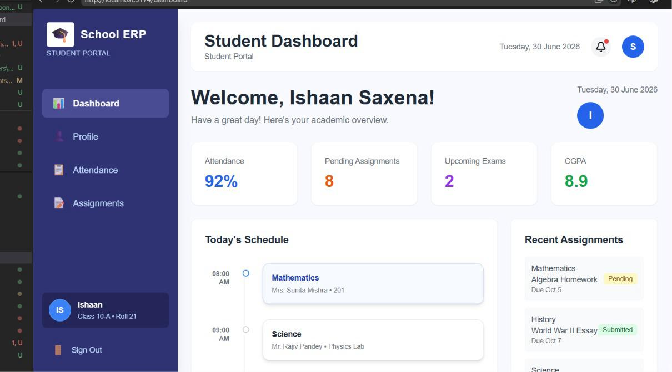
Student Dashboard – top section

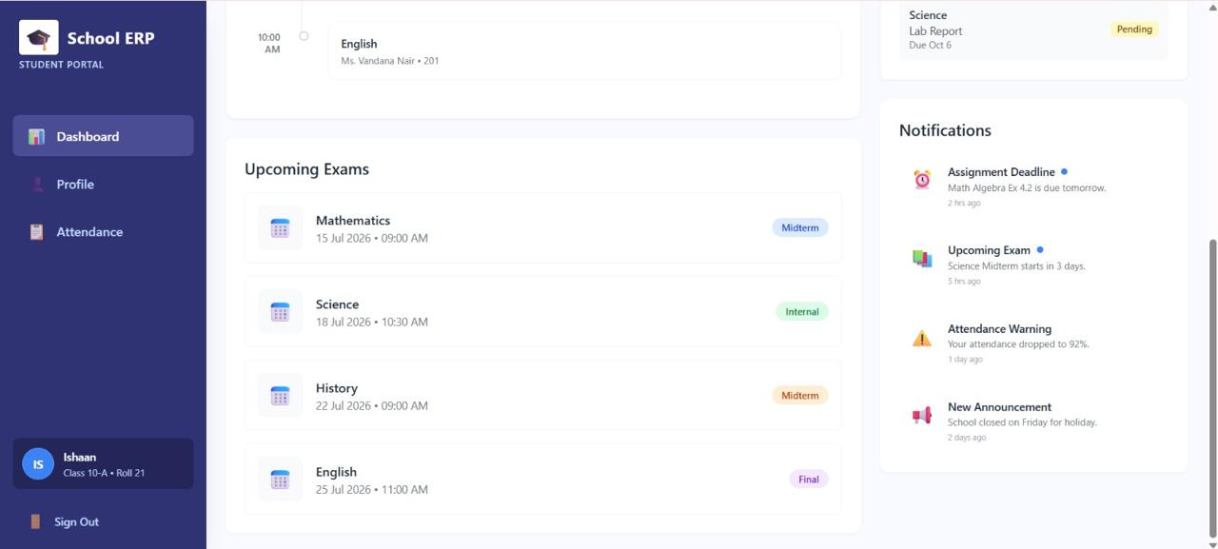
Student Dashboard - exams and notifications

SCR-007 – Student Profile
Purpose
Displays the student's personal, academic, and contact information in a read-only summary view.
Users
- Student
- Components
- Profile photo placeholder
- Student name
- Roll Number, Class, Section
- Email, Phone, Blood Group
- Parent Name
Validation
Fields are populated from the student's admission record and are read-only on this screen
Navigation
Dashboard menu item → back to Student Dashboard (SCR-006)

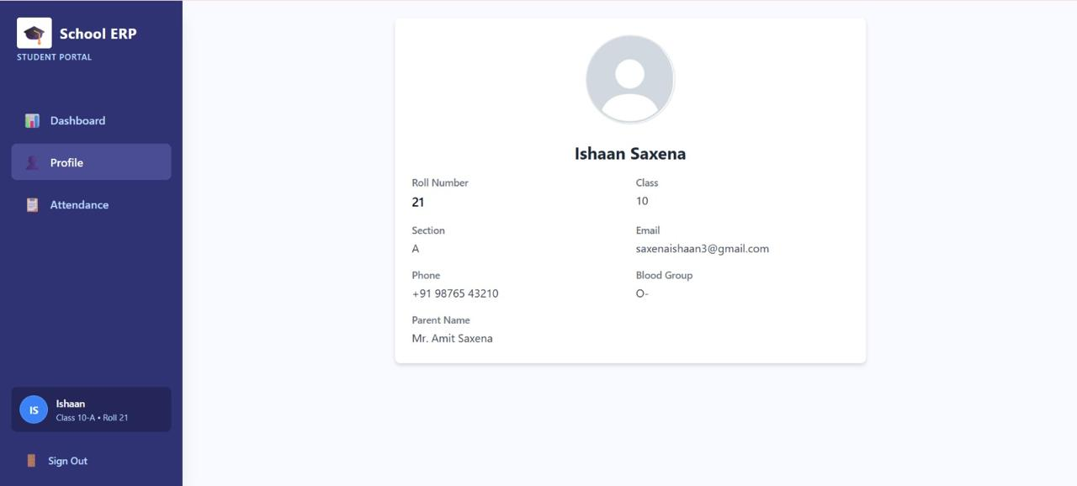
Student Profile screen

SCR-008 – Student Attendance
Purpose
Allows the student to review their monthly attendance calendar, key attendance statistics, and a day-wise attendance log.
Users
- Student
Parent (equivalent view for their child)
Components
- Summary cards – Overall Attendance %, Present Days, Absent Days, Late Arrivals
- Monthly calendar grid with colour-coded status indicators (Present / Absent / Holiday)
- Attendance Trend chart (last 7 days)
- Attendance log table – Date and Status
Validation
- Calendar and statistics reflect only the logged-in student's attendance records
- Status indicators are colour-coded (green = present, red = absent, grey = holiday/no record)
Navigation
Dashboard menu item → back to Student Dashboard (SCR-006)

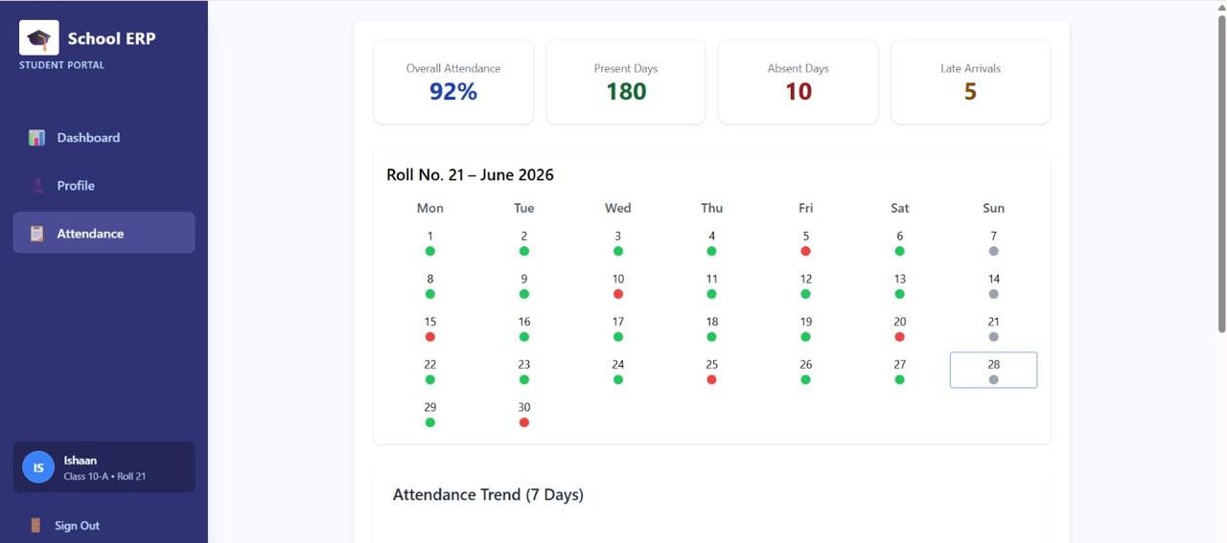
Attendance – monthly calendar and statistics

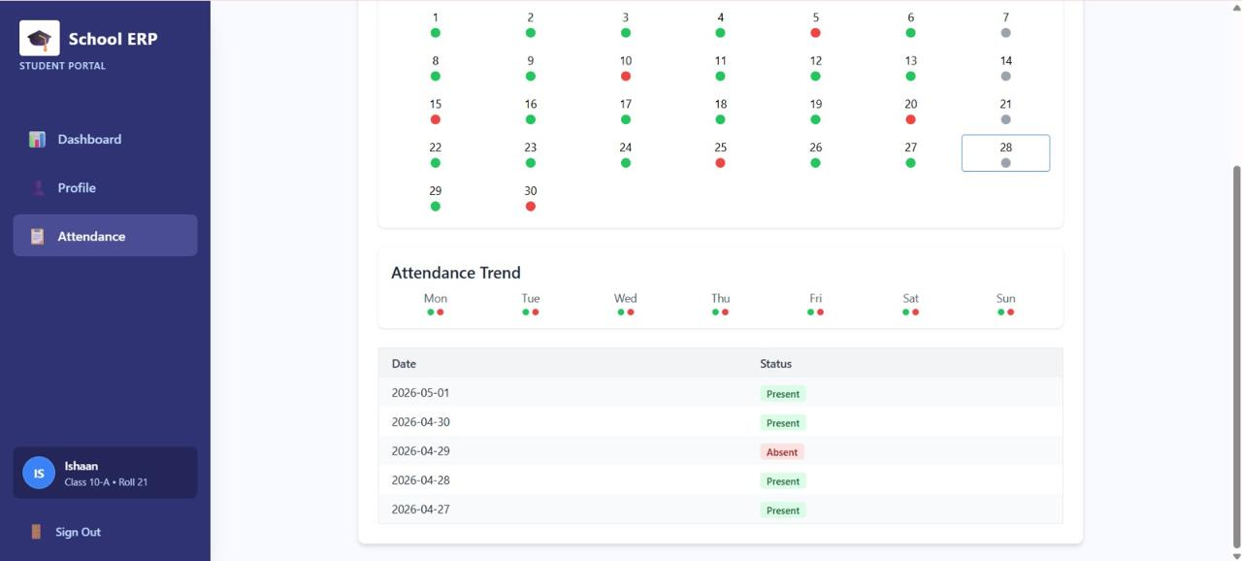
Attendance – trend chart and attendance log

SCR-009 – Examination & Results
Purpose
Displays the student's latest examination results, including subject-wise marks, grades, overall percentage, rank, and performance trend compared to the class average.
Users
- Student
- Parent (equivalent view for their child)
Components
- Summary cards – Total Marks, Percentage, Grade, Status (Passed/Failed), Rank, Class Average
- Subject-wise results table – Subject, Max Marks, Obtained Marks, Grade
- Performance Trends bar chart across subjects
Validation
- Results are shown only after they are published by the Admin/Teacher
- Status reflects Passed or Failed based on the school's configured passing criteria
Navigation
Dashboard menu item → back to Student Dashboard (SCR-006)
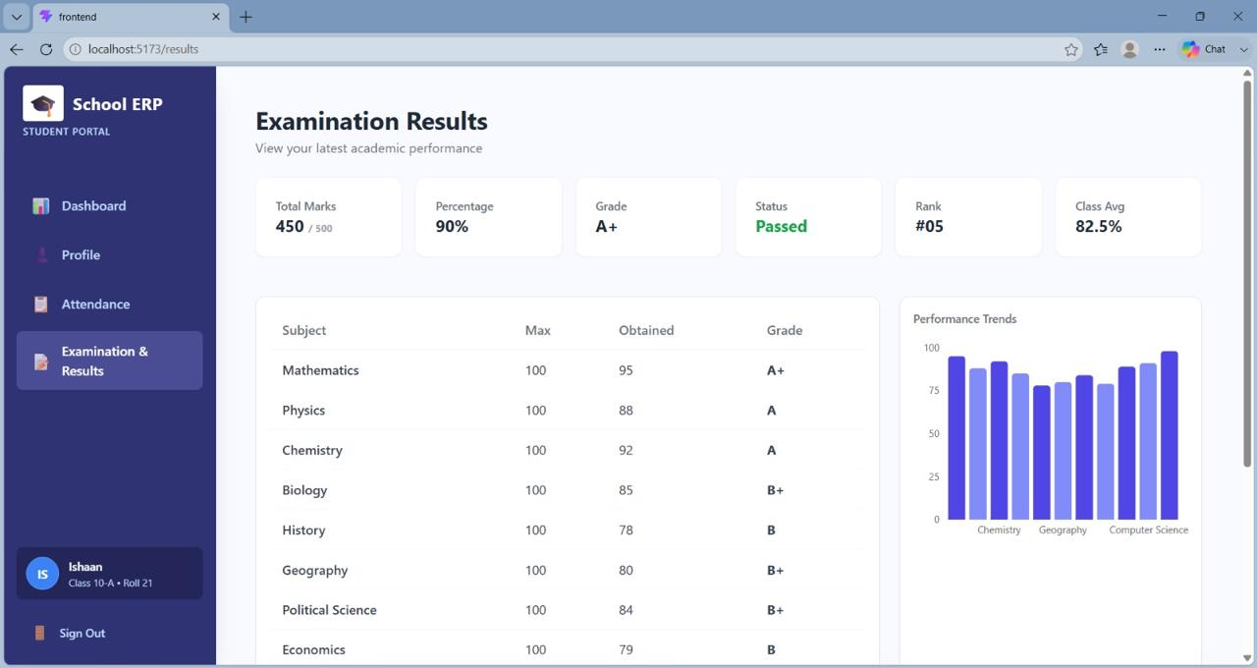
Examination Results screen

SCR-010 – Teacher Dashboard
Purpose
The Teacher Dashboard provides a centralized view of academic activities, allowing teachers to monitor student performance, manage attendance, review examination results, and access important classroom information.
Users
- Teacher
- Admin
Components
- Dashboard summary cards (attendance, assignments, performance, notifications)
- Performance analytics and quick action menu
Validation
- Only authenticated teachers and administrators can access the dashboard.
- Users can view only the data they are authorized to access based on their role.
Navigation
- Login → Teacher Dashboard
- Teacher Dashboard → Attendance, Student Marks, Notifications, Reports, and Profile pages
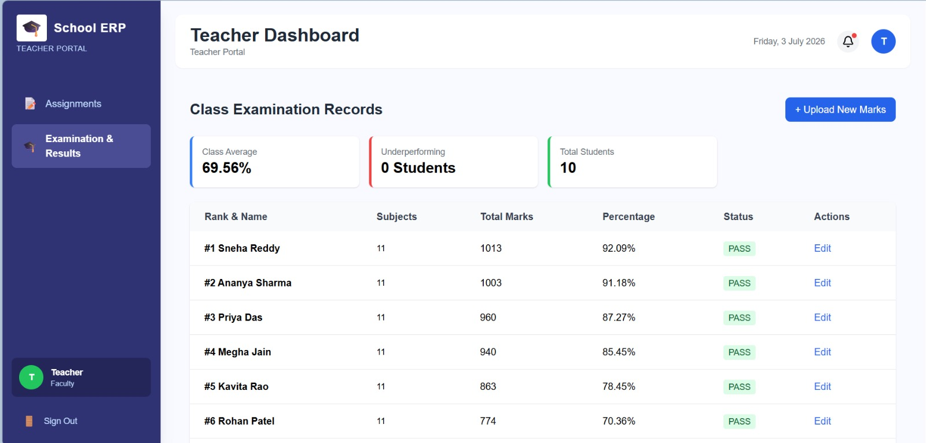
Screen Provides a Student performance, class average, percentage, status

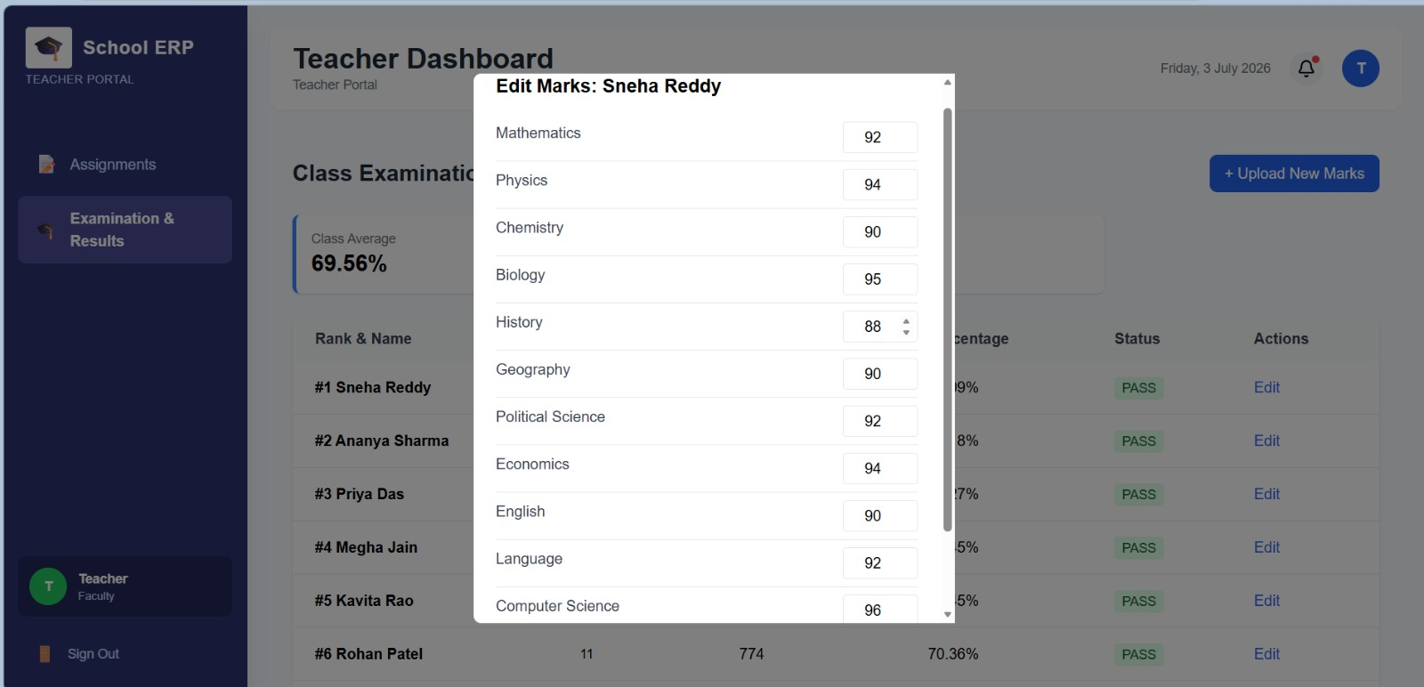

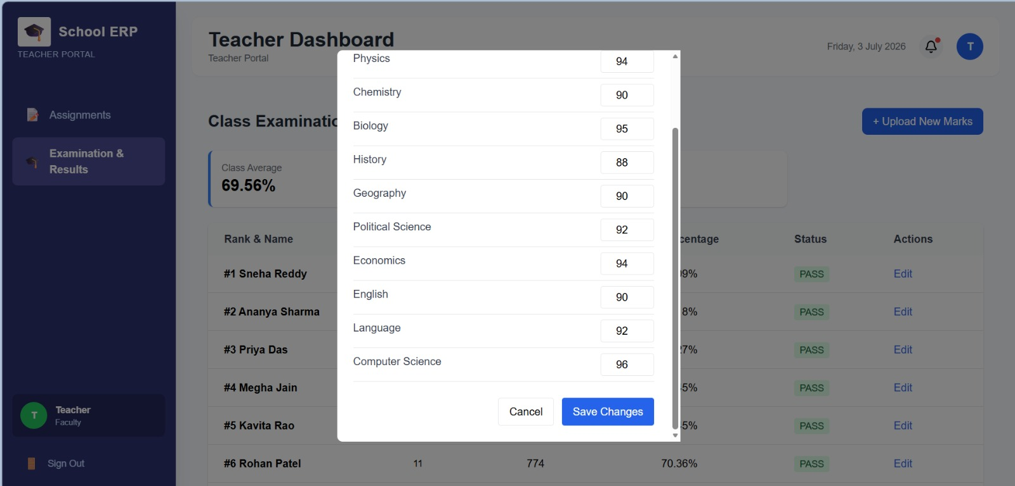

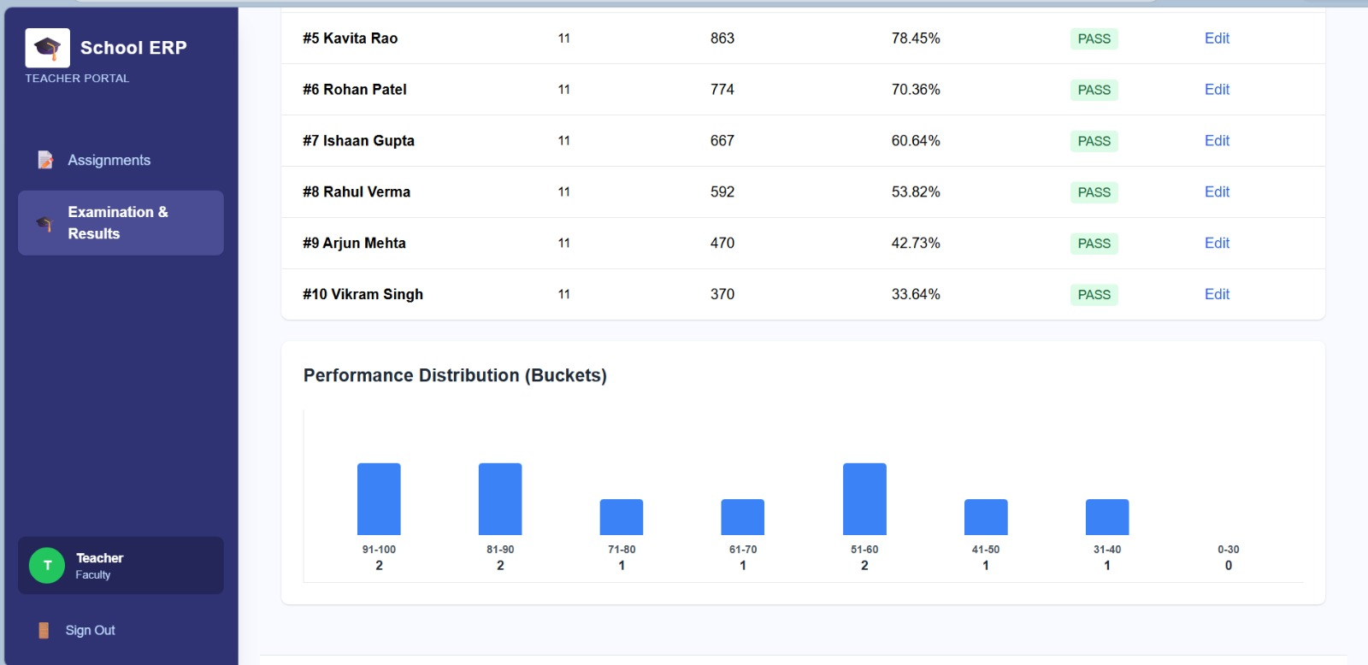
Displays students performance using score- range distribution charts

SCR-011 – Notification
Purpose
The Notifications screen allows users to view important announcements, updates, reminders, and system alerts. It ensures users stay informed about academic and administrative activities.
Users
- Student
- Admin
Components
- Notification list with title and message
- Date/time and notification status (read/unread)
Validation
- Only authenticated students can access their notifications.
- Students can view only the notifications assigned to them.
Navigation
- Student Dashboard → Notifications
- Notifications → Back to Student Dashboard

